DS.140 Integration Design Specification



Auto PO Close Integration

SCM_RICE_006

Author: Pranjul Garg

Creation Date: May 19, 2022

Last Updated: May 19, 2022

Version: 1.0

**Approvals:**

|  |  |
| --- | --- |
| <Approver 1> | <Rakesh Khanna / Naushad / Amit> |
| <Approver 2> | <Business Owner> |

# Document Control

## Change Record

| Date | Author | Version | Change Reference |
| --- | --- | --- | --- |
| 19-May-2022 | Pranjul Garg | 1.0 | No Previous Document |
|  |  |  |  |
|  |  |  |  |
|  |  |  |  |

2

## Reviewers

| Name | Position |
| --- | --- |
| FHL Business | Business User |
| FHL IT Group | Fortis IT Team |
|  |  |
|  |  |

Contents

1 Document Control ii

1.1 Change Record ii

1.2 Reviewers ii

2 Introduction 4

2.1.1 Scope for this Document 4

2.1.2 Intended Audience 4

3 Overview 5

3.1 Business Objectives 5

3.2 Major Features 5

3.3 Glossary 5

4 High-Level Fusion Integration flow 6

5 Technical Design Details 7

5.1 OIC Services 7

5.2 Oracle PaaS DBCS components 8

5.3 Technical flow 8

6 Data FIELD Mapping 13

6.1 File format 13

6.2 Frequency 13

7 Exception handling 14

7.1 Scenarios 14

8 Assumptions / Considerations 15

9 Open and Closed Issues 16

9.1 Open Issues 16

9.2 Closed Issues 16

# Introduction

### Scope for this Document

This analysis specification document is prepared to layout the design for an integration to auto close the PO based on need by date.

### Intended Audience

This document is intended for the following groups to provide the action items and consideration that are required to complete the implementation of the various Supply Chain and Finance related functionalities from Oracle Fusion.

#### Fortis Business Users

This document will be helpful for Fortis Business users to understand the technical design and process change with the new structure implemented in Oracle. The business user will validate this document after the verification of the requirement.

#### PwC Technical Team

The PwC technical team will use this document as a source technical design document to develop the technical solution to implement / deploy in Oracle Fusion.

#### Fortis IT Team

The Fortis IT Team must facilitate the PwC technical team for requisite details and other elements required from Business. The Fortis IT team is also responsible to arrange and provide required technical information wherever is required.

# Overview

Fortis Healthcare Limited (FHL) is a chain of hospitals, headquartered in India. Fortis started its health care operations from Mohali where first Fortis hospital was started. Later, the hospital chain purchased the healthcare branch of the Escorts group and increased its strength in various parts of the country. The Fortis health care also operates its hospital in Vasant Kunj, Faridabad, Gurgaon. The FMRI hospital at Gurgaon is the headquarter of Fortis healthcare with all the major facilities at the hospital.

This specification document is prepared to layout the design for an integration to auto close the PO based on need by date.

## Business Objectives

The following are the business objectives.

1. To have a secure, reliable, and scalable design flow to validate and close the PO line where need by date has been passed.
2. To have a solution providing the monitoring capabilities.

## Major Features

The proposed solution will have the following features involved:

1. OIC integration invokes Fusion BI report to fetch the eligible PO which should be cancelled.
2. The OIC integration then invokes a REST API to close the given PO.

## Glossary

REST

Representational State Transfer.

OIC

Oracle Integration Cloud

# High-Level Fusion Integration flow

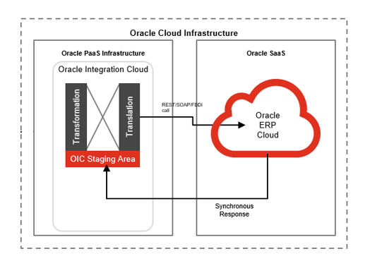

# Technical Design Details

This section describes the technical details of all the components involved in the design for an integration to auto close the PO based on need by date.

## OIC Services

An App driven orchestration has been designed in OIC to build a REST Endpoint URL:

|  |  |
| --- | --- |
| **OIC Integration Name** | Fortis Trigger PO Line Auto Cancellation Intg |
| **OIC REST Endpoint URL** | <https://oic-prod-nr5lr39yailj-bo.integration.ocp.oraclecloud.com:443/ic/api/integration/v1/flows/rest/FORT_TRIG_PO_LINE_AUTO_CANC_INTG/1.0/poLineCancel/> |
| **Method** | POST |

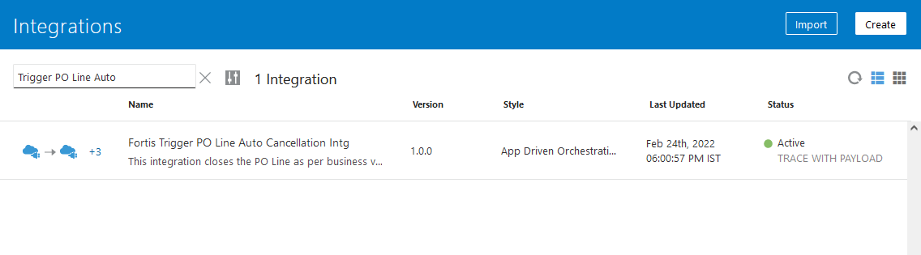

This is an app driven integration which is invoked via a following common scheduled OIC integration:

|  |  |
| --- | --- |
| **OIC Integration Name** | Fortis Trigger 60m Integration |
| **OIC REST Endpoint URL** | [NA](https://oic-prod-nr5lr39yailj-bo.integration.ocp.oraclecloud.com:443/ic/api/integration/v1/flows/rest/FORTIS_TRIG_GRN_PUT_AWAY_TXN_INT/1.0/grnPutAway/) |
| **Method** | NA |
| **Frequency** | Scheduled every 60 minutes |

This wrapper scheduled integration has been configured due to the limit of scheduled integrations within OIC. Hence all the required scheduled integrations have been clubbed together as per their required frequency.

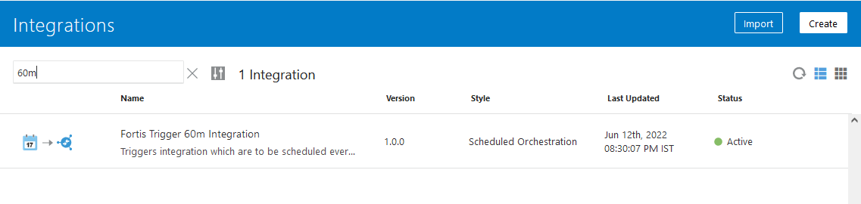

## Oracle PaaS DBCS components

This integration design does not use any DBCS related component.

## Technical flow

Following is the complete technical flow for this integration design:

1. A common scheduled OIC integration (Fortis Trigger 60m Integration) invokes this Auto PO cancellation integration.
2. This OIC integration first invokes a custom BIP report: Fortis PO Buyer Details Report to fetch all the distinct buyer email addresses where the respective PO line must be closed.
3. The OIC integration then invokes an ESS Job: Fortis Close Purchase Order Line (path: /oracle/apps/ess/custom/purchasing/PO_Line_Close/) which internally invokes BI Report: Fortis PO Line Close Report to fetch the eligible PO lines where need by date has been passed, by passing the buyer email id received from the above BIP report.
4. This BI report uses the following query to fetch the eligible PR lines:

SELECT PO_header_id,

po_number,

po_line_id,

line_num,

buyer_email,

'PO_LINE_CLOSE' KEY

FROM (SELECT pha.PO_header_id,

pha.segment1 po_number,

pla.po_line_id,

pla.line_num,

(SELECT pea.email_address

FROM PER_PERSON_NAMES_F ppf,

PER_ALL_ASSIGNMENTS_M paa,

PER_EMAIL_ADDRESSES pea

WHERE ppf.person_id = pha.agent_id

AND ppf.person_id = pea.person_id

AND ppf.name_type = 'IN'

AND paa.person_id = ppf.person_id

AND paa.assignment_type IN ('C', 'E')

AND pea.EMAIL_TYPE = 'W1'

AND paa.assignment_status_type = 'ACTIVE'

AND SYSDATE BETWEEN paa.effective_start_date

AND paa.effective_end_date

AND SYSDATE BETWEEN ppf.effective_start_date

AND ppf.effective_end_date)

buyer_email

FROM PO_HEADERS_ALL pha,

PO_LINES_ALL pla,

PO_LINE_LOCATIONS_ALL plla,

EGP_SYSTEM_ITEMS esi

WHERE pha.po_header_id = pla.po_header_id

AND pla.po_line_id = plla.po_line_id

AND pha.type_lookup_code = 'STANDARD'

AND pha.style_id <> 2

AND pla.line_status = 'OPEN'

/* AND NVL (trunc(plla.need_by_date), trunc(SYSDATE + 1)) <

(trunc(SYSDATE) - NVL (esi.days_late_receipt_allowed, 0))*/

AND trunc(plla.last_accept_date) < trunc(sysdate)

AND pla.item_id = esi.inventory_item_id

AND plla.ship_to_organization_id = esi.organization_id

UNION ALL

SELECT pha.PO_header_id,

pha.segment1 po_number,

pla.po_line_id,

pla.line_num,

(SELECT pea.email_address

FROM PER_PERSON_NAMES_F ppf,

PER_ALL_ASSIGNMENTS_M paa,

PER_EMAIL_ADDRESSES pea

WHERE ppf.person_id = pha.agent_id

AND ppf.person_id = pea.person_id

AND ppf.name_type = 'IN'

AND paa.person_id = ppf.person_id

AND paa.assignment_type IN ('C', 'E')

AND pea.EMAIL_TYPE = 'W1'

AND paa.assignment_status_type = 'ACTIVE'

AND SYSDATE BETWEEN paa.effective_start_date

AND paa.effective_end_date

AND SYSDATE BETWEEN ppf.effective_start_date

AND ppf.effective_end_date)

buyer_email

FROM PO_HEADERS_ALL pha,

PO_LINES_ALL pla,

PO_LINE_LOCATIONS_ALL plla,

PO_DISTRIBUTIONS_ALL pda,

EGP_SYSTEM_ITEMS esi

WHERE pha.po_header_id = pla.po_header_id

AND pla.po_line_id = plla.po_line_id

AND pla.quantity = plla.quantity_received

AND plla.line_location_id = pda.line_location_id

AND NVL (pda.consignment_quantity, 0) = 0

AND pla.line_status = 'OPEN'

AND pha.style_id = 2

AND pla.item_id = esi.inventory_item_id

AND plla.ship_to_organization_id = esi.organization_id

AND esi.inventory_item_flag = 'Y')

WHERE buyer_email = :p_buyer_email AND ROWNUM < 51

1. This OIC integration then invokes the following REST API for each & every record to cancel the given line:

|  |  |
| --- | --- |
| REST API URL | https://fa-ermg-saasfaprod1.fa.ocs.oraclecloud.com/fscmRestApi/resources/11.13.18.05/purchaseOrders/{POHeaderId}/child/lines/{POLineId} |
| Method | POST |
| Request Payload | {  "name" : "close",  "parameters" : [ {  "closeAction" : "close"  } ]  } |
| Response Payload | {  "result" : "SUCCESS"  } |

**Server details:**

|  |  |  |  |  |
| --- | --- | --- | --- | --- |
| **Server** | **Host name** | **Port** | **Service Name** | **Username** |
| Oracle PaaS DB | 140.238.225.129 | 1521 | PRODPDB1.fhpubsn.fhvcn.oraclevcn.com | XXFH & XXFH_RO |



# Data FIELD Mapping

NA

## File format

NA

## Frequency

The integration is scheduled to run every 60 minutes.

# Exception handling

There can be various scenarios for an error to occur. This section defines those error scenarios, and the exception handling has been done to notify and act accordingly.

## Scenarios

In a tabular format give list of scenarios and exception handling

* If any of the step or node fails within the OIC integration, Global Fault section is configured within this OIC integration to send an OIC error notification with relevant details.
* The email id has been stored in OIC Lookup: Fortis_FaultNotification_EmailAddress_Lookup against the given OIC integration name.
* It also sends a notification every 10 minutes with the details of the GRN which have been processed in the given run. This notification also acts as a confirmation that the integration has been running fine.

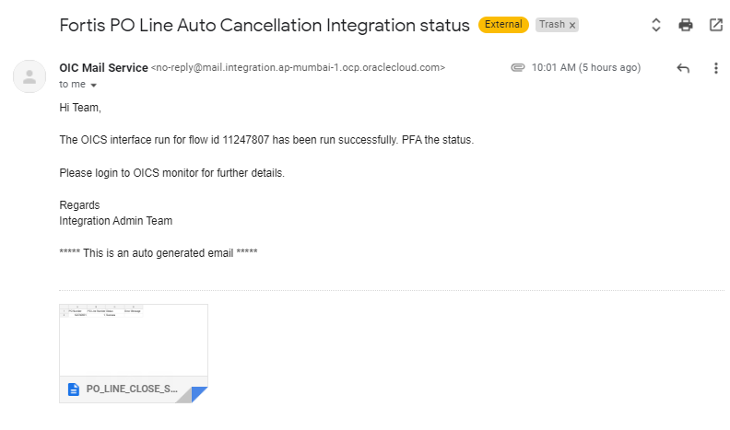

# Assumptions / Considerations

The Proposed Solution will have the following technical considerations.

In the future, if any product bug arises in functionality then this process needs to be revisited after the bug is fixed.

# Open and Closed Issues

## Open Issues

| ID | Issue | Resolution | Responsibility | Target Date | Impact Date |
| --- | --- | --- | --- | --- | --- |
|  |  |  |  |  |  |
|  |  |  |  |  |  |
|  |  |  |  |  |  |
|  |  |  |  |  |  |

## Closed Issues

| ID | Issue | Resolution | Responsibility | Target Date | Impact Date |
| --- | --- | --- | --- | --- | --- |
|  |  |  |  |  |  |
|  |  |  |  |  |  |
|  |  |  |  |  |  |
|  |  |  |  |  |  |